

Dr. John, Gould inc.

2017-01-29

Dr. Gould

79699 Williams Ville Suite 183, West Deannaland, FL 54610

Phone: 2143841355

Fax: 3680942507

**Re:** Brianna, Cooper

**PHN:** 603454331

**Birthdate:** 19-Jan-1968

**Address:** 06780 Andrews Highway, East Kellyview, TN 61607

**Patient number:** 3582780573

To Whom It May Concern:

This is a medical letter to state the above patient is pregnant with expected delivery date of 22-Apr-2025. Hoping this information is satisfactory for your requirements.

Thank you.

Sincerely,

Dr. John, Gould

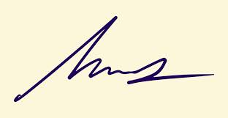

FRCS© NCMP

Clinical Assistant Professor, UBC

Department of Obstetrics and Gynecology SMH